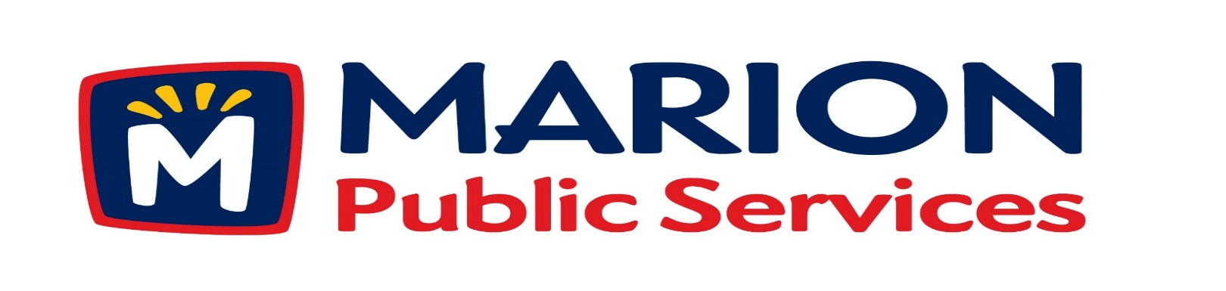

Minutes
Public Services Board
City of Marion
Tuesday, July 11th, 2017

Present: Craig Adamson, Tom Padley and Colleen Prokop
Absent: Mark Morgan, and Kevin Morgan
Staff: Ryan Miller and Diane Toy

- Approval of June 2017 Minutes.

- Motion to approve House Pickup Request.
  - Pazour 1609 3rd Avenue
- Review of Citizen Claim..
  - 1890 Oak Creek Drive
- Motion to Solicit Requests for Proposals for Commercial Solid Waste Collection Services (Art in the Alley Project).
- Discussion Regarding Eco Industrial Park Phase II – Retail Fuels Station.
- Motion to Approve Fiber Optic Lease Agreement with Linn-Mar Community School District.
- Old Business / New Business.
- Adjournment.

Minutes
Public Services Board
City of Marion
Tuesday, July 11th, 2017
Continued

ITEM 1 Approval of June 2017 Minutes.
Craig Adamson called to order the regular meeting of the Public Service Board on Tuesday, July 11th, 2017 at 12:03 PM. A motion to approve the June 2017 minutes was made by Tom Padley, seconded by Colleen Prokop, approved by all, Motion carried.

ITEM 2 Motion to approve House Pickup.
Ryan updated the PS Board that the house pick up at 1609 3rd Avenue is Council member Mary Lou Pazour, she had surgery and is unable to get her garbage to the curb at this time. The Solid Waste Supervisor went to the residence home and has recommended the service for the resident.. A motion was made by Tom Padley, seconded by Colleen Prokop, all members agreed, Motion carried.

ITEM 3 Review of Citizen Claim
Ryan explained that the resident claimed we hit her mailbox while plowing and broke the post. The plow driver called in that the mailbox was down prior to him plowing the street, during the storm we did not curb the snow we only cut and centered the residential streets. We have pictures that the Street Supervisor took, and we put a temporary mailbox because we did not know we did not hit the mailbox. We have the following options: Do nothing. Put up a replacement post and mailbox or we can issue a check for $25.00. The PS Board has denied the claim and Ryan will send the resident a letter to explain this decision. A motion was made by Craig Adamson, seconded by Tom Padley, approved by all, Motion carried.

Minutes
Public Services Board
City of Marion
Tuesday, July 11th, 2017
Continued

ITEM 4 Motion to Solicit Requests for Proposal for Commercial Solid Waste Collection Services (Art in The Alley Project).
Ryan updated the PS Board on the request from the City Manager’s office that we sent out and RFP that includes options for collecting the solid waste in the Art in the Alley and also expanding to include collecting solid waste from community events and future city facilities. This would be managed by the PS Board and Public Service Department, we will bill the addresses and we will pay the private hauler. Ryan sees this as a growing service, currently we inspect the private haulers trucks and issue yearly permits. We would control the pickup days and number of days per week and as businesses grow we would like the program to be flexible to change days and container size and would start with a 3 year contract that could be extended for another year. We will inform the businesses and supply them with the information. Craig would like yearly reminders sent out each year so any new business would have the current information and Ryan would like signs put on the containers or enclosure with contact information for the private hauler. A motion was made by Tom Padley, seconded by Colleen Prokop to send out the RFP and once a private hauler is selected and will then go to the City Council for approval, approved by all, Motion carried.

ITEM 5 Discussion regarding Eco Industrial Park Phase II – Retail Furls Station.

Ryan updated the PS Board about changes to the Retail Fuels Station, plans have changed and a new retail company has expressed an interest in the station. Looking at a company that will offer fuel cost savings to the city for its fuel needs, the fuel margin in fuel prices over rack prices is $.20 - $.50 per gallon. Rack price is wholesale price plus delivery which is $.01 to $.03, cost for diesel fuel should be around $1.53 per gallon and we are paying $2.30 per gallon and the City of Marion uses approximately 150,000 to 200,000 gallons per year. Future discussion with the PS Board will be what services will the station provide beyond the fuels service? The first step will be to move forward with executing a letter of intent with the company and will keep the PS Board up to date on the progress. A motion was made by Tom Padley, seconded by Colleen Prokop to move forward, approved by all, Motion carried.
Minutes
Public Services Board
City of Marion
Tuesday, July 11th, 2017
Continued

ITEM 6 Motion to approve Fiber Optic Lease Agreement with Linn-Mar Community School District.

Ryan explained that the City of Marion needs to lay fiber on HWY 13 to the Medco Business center and have Linn-Mar Transportation facility connect into it. The Linn- Mar Community School District will pay a portion of the future perpetual maintenance cost and enter into a 99 year fiber lease, A motion was made by Tom Padley, seconded by Colleen Prokop to move that we approve the laying the fiber and the lease agreement, approved by all, Motion carried.

Item 7 Old Business / New Business
New business – The Early Grading package went out and is due back by 7/28/2017 at 10:00 AM. Ryan will have the company that won the bid at the next meeting.
Indian Creek by golf course is HMA overlay on the 3 year plan.

ITEM 8 Adjournment.
The meeting was adjourned at 1:13 PM by Craig Adamson. A motion was made by Tom Padley, seconded by Colleen Prokop, approved by all, Motion carried.

Minutes
Public Services Board
City of Marion
Tuesday, July 11th, 2017
Continued

Next PSB meeting is scheduled for Tuesday, August 8th, 2017 at noon.

Respectfully submitted by:

____________________
Ryan Miller
Public Service Director

RM/dpt

