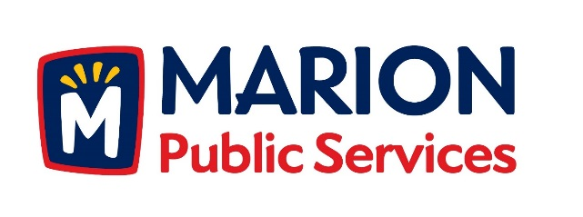

CITY OF MARION PUBLIC SERVICE BOARD
AGENDA
Noon
August 8th, 2017

- Approval of July 2017 Minutes.

- Motion to Approve House Pickup Request.

-Newhall-4412 Pepperwood Hill SE

- Discussion Regarding Project Delivery for the Eco Industrial Park.

- Old Business/New Business.

- Adjournment.

