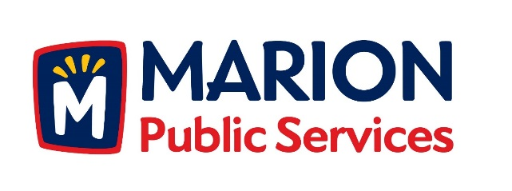

CITY OF MARION PUBLIC SERVICE BOARD
AGENDA
Noon
September 12th, 2017

- Approval of August 2017 Minutes.

- Motion to Approve House Pickup Request.

-Armstrong-2730 11th Avenue

- Discussion Regarding Request for Qualifications for Contract Manager at Risk.

- Motion to Approve Request for Qualifications for the Contract Manager at Risk.

- Discussion Regarding Structural Assessment Study for Signalized Intersections.

- Old Business/New Business.

- Adjournment.

