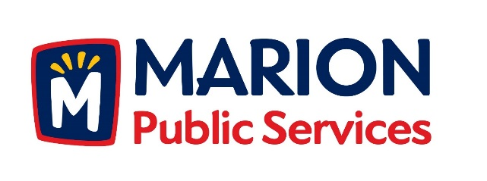

CITY OF MARION PUBLIC SERVICE BOARD
AGENDA
Noon
April 11th, 2017

- Approval of March 2017 Minutes.

- Motion to Approve the Public Service Work Schedule for 2017.

- Discussion Regarding Strategic Goals for the Public Services Department.

- Discussion Regarding Wastewater Treatment Agreement with the City of Cedar Rapids.

- Old Business/New Business.

- Adjournment.

