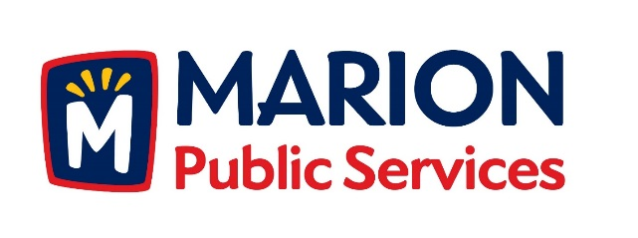

CITY OF MARION PUBLIC SERVICE BOARD
AGENDA
Noon
March 21, 2017

- Approval of February 2017 Minutes.

- Motion to Approve Solid Waste House Pickup Requests.

  - Harper-1539 5th Avenue

- Discussion Regarding Eco Industrial Park Development.

- Motion to Direct Staff to Complete Financing and Project Documents for the Eco Industrial Park Development.

- Old Business/New Business.

- Adjournment.

