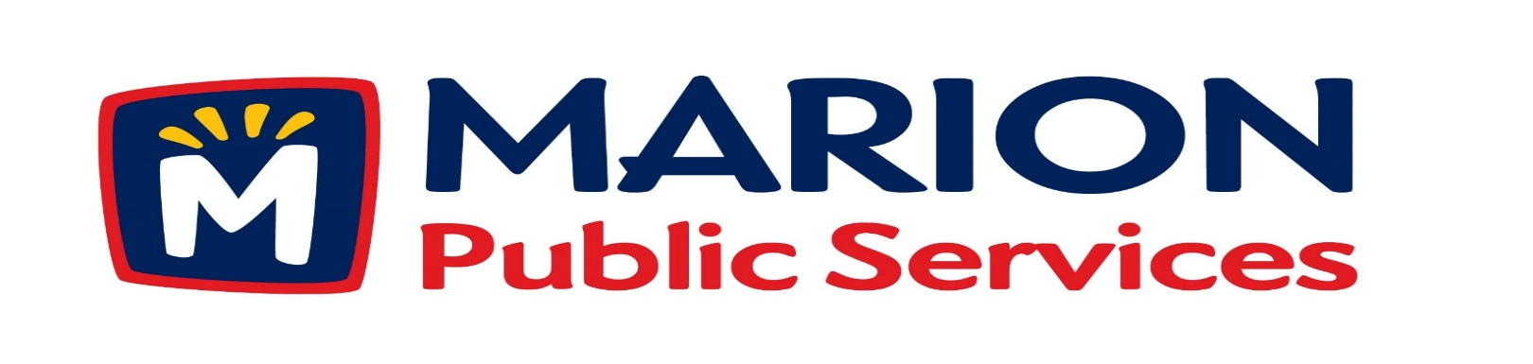

Minutes
Public Services Board
City of Marion
Wednesday, January 10th, 2016

Present: Kevin Morgan, Mark Morgan, Tom Padley, and Craig Adamson
Absent: Colleen Prokop
Staff: Ryan Miller and Diane Toy

- Approval of December 2016 Minutes.
- Motion to Approve Solid Waste House Pickup Request.
  - Nees-1325 2nd Avenue
  - Pantini-4408 Indian Creek Road
  - Murdoch-3405 Hemingway St
  - Etzel-3400 10th Street

- Motion to Approve 2017 Solid Waste Holiday Collection Schedule.
- Discussion Regarding Sanitary Sewer Fees.
- Discussion Eco Industrial Development.
- Old Business / New Business.
- Adjournment.

Minutes
Public Services Board
City of Marion
Wednesday, January 10th, 2016
Continued

ITEM 1 Approval of December 2016 Minutes.
Mark Morgan called to order the regular meeting of the Public Service Board on Wednesday, January13th, 2016 at 12:04 PM. Craig Adamson arrived at 12:10 PM. A motion to approve the December 2016 minutes was made by Tom Padley, seconded by Kevin Morgan, approved by all, Motion carried.

ITEM 2 Motion to Approve Solid Waste House Pickup Request.
The following residents have requested Solid Waste House collection a service we provide for handicap or elderly residents. The Nees’ reside at 1325 2nd Ave, the Pantini’s reside at 4408 Indian Creek Rd, the Murdoch’s reside at 3405 Hemingway St, and the Etzel’s reside at 3400 10th St, all have health issues and are elderly. A motion was made by Tom Padley, seconded by Craig Adamson, to approve the request, all members agreed, Motion carried.

ITEM 3 Motion to Approve 2017 Solid Waste Holiday Collection Schedule.
Ryan talked to the PS Board about the Solid Waste Agency’s Holiday closure schedule for 2017, pretty straight forward and we work with it during the year. We collect the curbside solid waste Monday to Saturday of that week, skipping the holiday closure. The only time we have a problem with collection and dumping the trucks is when the landfill closes early because of high winds, we have to empty first thing the next morning then do the routes and empty at the end of collections. A motion was made by Craig Adamson, seconded by Tom Padley to accept the Holiday schedule, approved by all, Motion carried.

Minutes
Public Services Board
City of Marion
Wednesday, January 10th, 2016
Continued

ITEM 4 Discussion Regarding Sanitary Sewer Fees.

Ryan talked to the PS Board about the notice that the City of Cedar Rapids sent to us about an 18% increase in the sewer fees starting July 2017. We will have to do a rate increase to residents to cover the increase and Ryan would like to spread it out and the PS Board would like the rate increase to be explained on resident’s bill and on the website. The new flow meters we installed are accurately tracking our water flow but The City of Cedar Rapids has not signed a new flow usage agreement with us at this time. The PS Board would like Ryan and the City Manager to have a plan on how to get the new agreement signed and in place in a very timely manner. We need to be prepared on our end with whatever is necessary including any correspondence from our City Manager and or legal department to the City of Cedar Rapids City Manager and City Council members as a receive and file and have an update no later than 3/10/17. A motion was made by Craig Adamson, seconded by Mark Morgan, to approve the request, all members agreed, Motion carried.

Item 5 Discussion Regarding Eco Industrial Park.
Ryan updated the PS Board on the plans for the Eco Industrial Park and went over the book he had put together for the City Council and the power point that he was presenting to them at the City Council Work session on January 10th, 2017. He talked about the history of the current buildings and how the whole Eco Industrial Park plan came about as a way to build the park and save money started in 2010. Will be phasing in new CNG vehicles in stages and would like to start with the Solid Waste fleet, this is the oldest fleet we have and is used every day and they have been in production and are being used all over the country the longest and have the best support out in the field. Ryan is looking at cab over design they give you the best visual of all truck designs. Ryan will update the PS Board as information is available.

Minutes
Public Services Board
City of Marion
Wednesday, January10th, 2016
Continued

ITEM 6 Old Business / New Business.
Ryan stated that the 2016/2017 year was the most plats he has ever seen for the city.
State of the City Lunch – Mark, Tom and Kevin - NO, Craig and Colleen – YES.

ITEM 8 Adjournment.
The meeting was adjourned at 2:00 PM by Craig Adamson. A motion was made by Craig Adamson, seconded by Mark Morgan, approved by all, Motion carried.

Next PSB meeting is scheduled for Tuesday, February 14th, 2017 at noon.

Respectfully submitted by:

____________________
Ryan Miller
Public Service Director

RM/dpt

