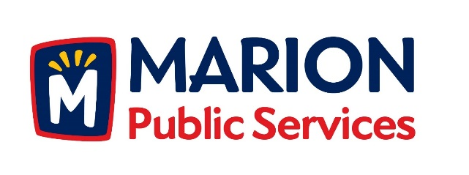

CITY OF MARION PUBLIC SERVICE BOARD
AGENDA
Noon
January 10th, 2017

- Approval of December 2016 Minutes.

- Motion to Approve Solid Waste House Pickup Requests

Nees-1325 2nd Avenue
Pantini-4408 Indian Creek Road
Murdoch-3405 Hemingway St.
Etzel-3400 10th Street

- Motion to Approve 2017 Solid Waste Holiday Collection Schedule

- Discussion Regarding Sanitary Sewer Fees

- Discussion Regarding Eco Industrial Park

- Old Business/New Business.

- Adjournment.

