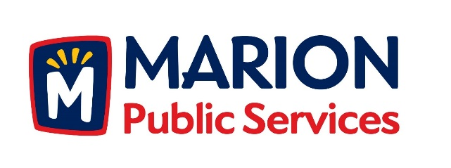

CITY OF MARION PUBLIC SERVICE BOARD
AGENDA
Noon
December 13th, 2016

- Approval of November 2016 Minutes.

- Motion to Approve the 2016/2017 Snow and Ice Program

- Discussion Regarding Open House and Receptions Policy

- Discussion Regarding Recycling Services.

- Discussion Regarding Solid Waste Fees.

- Update on Eco Industrial Development.

- Old Business/New Business.

- Adjournment.

