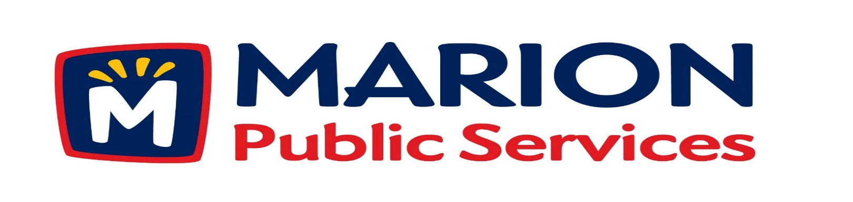

Minutes
Public Services Board
City of Marion
Wednesday, November 8, 2016

Present: Kevin Morgan, Colleen Prokop, Tom Padley, and Craig Adamson
Absent: Mark Morgan
Staff: Ryan Miller and Diane Toy

- Approval of October 2016 Minutes.
- Motion to Approve Application for Solid Waste House Collection Services:
  - Hinman-6205 East Kacena
  - Heddinge-3190 Willowridge #A

- Discussion Regarding Chapter 26 Public Services Board (26.04 Compensation)
- Review of Preliminary 2017/2018 Fiscal Year Budgetary Requests.
- Update on Eco Industrial Development.
- Old Business / New Business
- Adjournment

Minutes
Public Services Board
City of Marion
Wednesday, November 8, 2016
Continued

ITEM 1 Approval of October 2016 Minutes.
Craig Adamson called to order the regular meeting of the Public Service Board on Wednesday, November 8th, 2016 at 12:05 PM. A motion to approve the October 2016 minutes was made by Tom Padley, seconded by Colleen Prokop, approved by all, Motion carried.

ITEM 2 Motion to Approve Applications for Solid Waste House Collection.
The following residents have requested Solid Waste House collection a service we provide for handicap or elderly residents. The Lillie’s reside at 3170 Sunburst Avenue, the Hinman reside at 6205 East Kacena, and the Heddinge’s reside at 3190 Willowridge #A, all have health issues and are elderly. A motion was made by Kevin Morgan, seconded by Colleen Prokop, to approve the request, all members agreed, Motion carried.

ITEM 3 Discussion Regarding Chapter 26 Public Service Board (26.04 Compensation).
Ryan talked to the PS Board about the PS Board members having a stipend so they can do recognitions for the PS Service employees (ie: certificates, snacks, lunch). Waste Not Iowa group is disbanding and would like to donate the money to the City of Marion Public Service Department. Ryan would like the PS Board to oversee the money and place it in an account. Other City board members receive stipends the Park’s Board receives $500.00 / year. Water Board and City Council are more need to decide if the PS Board members would like to get a stipend which you will receive a W-2 or have lunch every month. We have formed a 501.C3 for the PS Board and can use this account to do some community service project, we have purchased flags and put the up throughout the city a few times a year and we also raised money for Marion cares. We can also look into volunteering our services and non-profit groups and have them make a donation to the fund. City policies are limited as to what can be done and the auditors have limited how funds can be used – it must be a benefit to the public. Ryan is going to talk to the City Manager on getting a liaison from the City Council to come to the PS Board meetings each month and how to proceed. A motion was made by Craig Adamson to have Ryan look into this, seconded by Colleen Prokop, approved by all, Motion carried.

Minutes
Public Services Board
City of Marion
Wednesday, November 8, 2016
Continued

ITEM 4 Review of Preliminary 2017/2018 Fiscal Year Budgetary Requests.

Ryan is looking at the growth of the city and out staffing needs for snow removal and work schedules. Looking at 2-4 IFTE operators for growth and retirements and transfers out of the department. Internal specialist positions that will allow for professional growth among employees of the current department. Addition of position to assist the Public Service Director and reorganize how we operate. Looking at the funding for the new Eco Industrial Park and equipment. The final budgets are due in February and sent to the state by March 2017.

Item 5 Update on Eco Industrial Development.
Ryan updated the PS Board on the upgrades to the natural gas pipeline to the area. We are working on the roadway grade, right now the roadway grade is higher than building. Ryan has a meeting with Cenex on 11/9/16 to talk about the fueling station and being a part of the project. Ryan is working with a steel building manufacturer on the building design to get numbers and plans and a time frame. Ryan is also looking at other companies to be a part of the Eco Industrial park. Ryan will keep the PS Board updated on the project as the plans are finalized.
No action required from the PS Board at this time.

ITEM 6 Old Business / New Business.
Questions on the 29th Ave & 35th St mini round-about, since the City owns the 2 lots what are the plans for the parcels in the future? Ryan said the City plans to keep the property but one resident that backs up to one of the lots was going to be able to sign a hold harmless and put up a privacy fence and do some landscaping.
Prince Aggregate land on 7th Ave what are the plans: there is some interest from a hotel / convention cent to possibly build there.
Art in the Alley: is moving forward and the art and lights are being installed.

Minutes
Public Services Board
City of Marion
Wednesday, November 8, 2016
Continued

ITEM 8 Adjournment.
The meeting was adjourned at 1:20PM by Craig Adamson. A motion was made by Tom Padley, seconded by Colleen Prokop, approved by all, Motion carried.

Next PSB meeting is scheduled for Tuesday, December 13th, 2016 at noon.

Respectfully submitted by:

____________________
Ryan Miller
Public Service Director

RM/dpt

