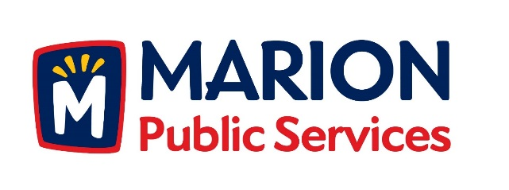

CITY OF MARION PUBLIC SERVICE BOARD
AGENDA
Noon
November 8th, 2016

- Approval of October 2016 Minutes.

- Review of House Pickup Requests

Hinman-6205 East Kacena
Heddinge-3190 Willowridge #A

- Discussion Regarding Chapter 26 Public Services Board (26.04 Compensation)

- Review of Preliminary 2017/2018 Fiscal Year Budgetary Requests.

- Update on Eco Industrial Development.

- Old Business/New Business.

- Adjournment.

