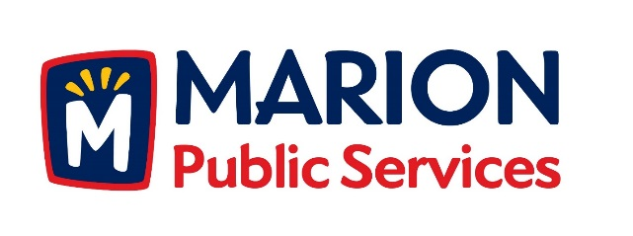

CITY OF MARION PUBLIC SERVICE BOARD
AGENDA
Noon
October 19th, 2016

- Approval of September 2016 Minutes.

- Motion to Approve Application for Solid Waste House Collection Services.
  - Lillie-3170 Sunburst Avenue
  - Hilsenbeck-600 Heather Ct.
  - Hoffman-2370 1st Avenue
  - Betzer-600 West 8th Avenue

- Review of Citizen Claims.
Bump-1660 2nd Avenue (Driveway)

- Discussion Regarding Municipal Solid Waste Collections for Single Family Dwellings.

- Discussion Regarding 28E Agreement with the Marion Independent School District.

- Update on Eco Industrial Development.

- Old Business/New Business.

- Adjournment.

