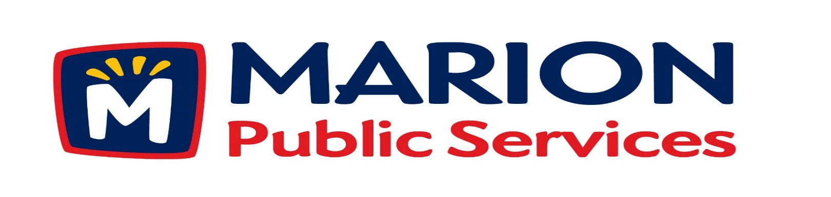

Minutes
Public Services Board
City of Marion
Tuesday, September 13, 2016

Present: Kevin Morgan, Colleen Prokop, Mark Morgan, and Craig Adamson
Absent: Tom Padley
Staff: Ryan Miller and Diane Toy

- Approval of August 2016 Minutes.
- Motion to Approve Application for Solid Waste House Collection Services:
  - Crouse – 3490 26th Avenue
  - Schultz – 2770 14th Avenue
  - Starr – 1780 Henderson Drive
- Discussion Regarding Support for Community Events.
- Update on Eco Industrial Development.
- Old Business/New Business.
- Adjournment.

Minutes
Public Services Board
City of Marion
Tuesday, September 13, 2016
Continued

ITEM 1 Approval of August 2016 Minutes.
Craig Adamson called to order the regular meeting of the Public Service Board on Tuesday, September 9, 2016 at 12:06 PM. A motion to approve the August 2016 minutes was made by Mark Morgan, seconded by Kevin Morgan, approved by all, Motion carried.

ITEM 2 Motion to Approve Applications for Solid Waste House Collection.
The following residents have requested Solid Waste House collection a service we provide for handicap or elderly residents. The Crouse’s reside at 3490 26th Avenue, the Schultz’s reside at 2770 14th Avenue, and the Starr’s reside at 1780 Henderson Drive all have health issues and are elderly. A motion was made by Mark Morgan, seconded by Colleen Prokop to approve the request, all members agreed, Motion carried.

ITEM 3 Discussion Regarding Support Services for Community Events.
Ryan talked to the PS Board about how the state is watching what services are offering at a discounted rate. Ryan spoke with the Arts Festival organizers and was told they are losing money and cannot pay for all the services, the race is run by an outside company and is for profit. The race will give the Arts Festival money after all expenses are paid. Mark said Foster’s has been paying for the Port O Jonny’s every year and just pays the cost increase. The PS Board asked the following questions:
Do we ask the Arts Festival to change their business plan?
Do they look for other sponsors?
They have 5 sponsors that give $10,000.00 each and have added 4 more sponsors.

Minutes
Public Services Board
City of Marion
Tuesday, September 13, 2016
Continued

ITEM 3 Discussion Regarding Support Services for Community Events continued.

The Swamp Fox Festival is run by all volunteers and is under the Parks Department. The PS Board said we should reconsider what we charge these groups for our services and should look at charging the Arts Festival the following – last year $900.00, next year $1300.00 then be charged for the actual cost the following year. We should watch what the State decides, they may come up with a plan to help cities run these festivals. Ryan will need to have face to face conversations with the organizations and make sure they are done early in the planning stage so everyone is in agreement. A motion was made to move forward with talks with the organizers, made by Mark Morgan, seconded by Colleen Prokop, approved by all, Motion carried.

Item 4 Update on Eco Industrial Development.
Ryan updated the PS Board on the progress of the Eco Industrial Park Development. The following items are in the final stages or have been completed:
Energy audit (fuel) has been completed and info is being prepared for final report.
Discussions with developers / contractors to facilitate design and build the facilities.
Completing final site plan / preliminary construction documents.
Infrastructure Finance agreement for underwriters / placement of lease certificates.
Objective to put the infrastructure into the ground and perform an energy savings audit. Ryan hopes to have everything in place to present to the City Council by next month

No action required from the PS Board at this time.

Minutes
Public Services Board
City of Marion
Tuesday, September 13, 2016
Continued

ITEM 5 Old Business / New Business.
Quick Star will be opening up a station in Marion.
Businesses are looking moving to Marion on 7th Ave by the new round about
Contractor is hoping to have 6th Ave done by next year.

ITEM 6 Adjournment.
Meeting was adjourned at 1:18PM by Craig Adamson, to adjourn the meeting. A motion was made by Mark Morgan, seconded by Colleen Prokop, approved by all, Motion carried.

Next PSB meeting is scheduled for Tuesday, October 11th , 2016 at noon.

Respectfully submitted by:

____________________
Ryan Miller
Public Service Director

RM/dpt

