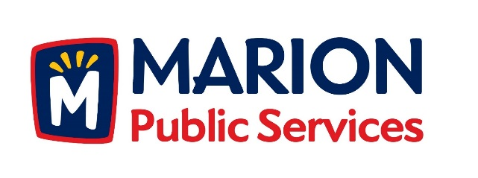

CITY OF MARION PUBLIC SERVICE BOARD
AGENDA
Noon
September 13th, 2016

- Approval of August 2016 Minutes.

- Motion to Approve Application for Solid Waste House Collection Services.
  - Crouse-3490 26th Avenue
  - Schultz-2770 14th Avenue
  - Starr-1780 Henderson Drive

- Discussion Regarding Support Services for Community Events.

- Update on Eco Industrial Development.

- Old Business/New Business.

- Adjournment.

