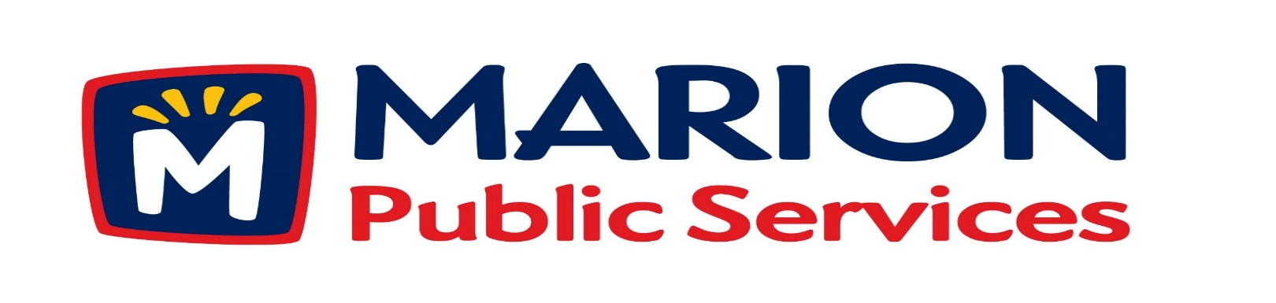

Minutes
Public Services Board
City of Marion
Tuesday, August 9, 2016

Present: Kevin Morgan, Colleen Prokop, Mark Morgan, and Tom Padley
Absent: Craig Adamson
Staff: Ryan Miller and Diane Toy

- Approval of July 2016 Minutes.
- Motion to Approve Application for Solid Waste House Collection Services:
  - Johnson – 3114 35th Avenue
  - Wilson – 4113 Garnett Circle
- Discussion Regarding Solid Waste Exemptions.
- Discussion Regarding Sanitary Sewer Fees.
- Update on Eco Industrial Development.
- Motion to Approve Engineering Services Agreement with Anderson Bogert (Eco Industrial Park 2nd & 3rd Addition).
- Old Business/New Business.
- Adjournment.

Minutes
Public Services Board
City of Marion
Tuesday, August 9, 2016
Continued

ITEM 1 Approval of July 2016 Minutes.
Mark Morgan called to order the regular meeting of the Public Service Board on Tuesday, August 9, 2016 at 12:07 PM. A motion to approve the July 2016 minutes was made by Tom Padley, seconded by Colleen Prokop, approved by all, Motion carried.

ITEM 2 Motion to Approve Applications for Solid Waste House Collection.
The following residents have requested Solid Waste House collection a service we provide for handicap or elderly residents. The Johnson’s reside at 3114 35th Ave and the Wilson’s reside at 4113 Garnett Circle both have health issues and are elderly. A motion was made by Tom Padley, seconded by Kevin Morgan to approve the request, all members agreed, Motion carried.

ITEM 3 Discussion Regarding Solid Waste Exemptions.
Ryan talked to the PS Board about reviewing the senior discount that we are offering and he talked to the City Council about 2 years ago, about how this service is discriminating. The Water Department uses the Federal Poverty guidelines, 2016 Federal government uses the HUD levels section 8 housing as guidelines. In 2016 – 2017 fiscal year Ryan is asking for a rate increase from $14.00 to $14.25 and senior rate increase from $10.50 to $11.00. On August 3, 2016 the City of Cascade is being audited by the Office of the Auditor of the State of Iowa for offering discounts to employees and seniors. Our legal counsel is looking into this and found out we cannot offer any reduction to any class for this is illegal, they are also looking other services that are offered at a free or reduced rate. We need to be consistent even with non-profits. We are waiting to see what the outcome with the audit of City of Cascade. A motion was made to move wait for the ruling on the audit for the City of Cascade, made by Tom Padley, seconded by Colleen Prokop, approved by all, Motion carried.

Minutes
Public Services Board
City of Marion
Tuesday, August 9, 2016
Continued

Item 4 Discussion Regarding Sanitary Sewer Fees.
Ryan updated the PS Board about the new Letter of Agreement signed by both the City of Cedar Rapids and the City of Marion that offers us the same agreement as the City of Hiawatha, which is a flow meter usage cost. A new business would like to move to Medco and would need to obtain a permit from the City of Cedar Rapids to be a larger wastewater user. We received the attached letter from the Utilities Director from the City of Cedar Rapids stating that the City of Marion does not have available wastewater treatment capacity. Ryan is in discussions with the City Council to see where this will go and we are waiting on guidance from our legal counsel. Legally the City of Cedar Rapids must take our waste water, Ryan will keep the PS Board updated on this item. Heavy users in the City of Marion are mobile home parks because they have only 1 meter for the whole park, while a single family home pays a meter fee. Ryan is trying to find a direction to come up with a fair rate for everyone, we need to encourage residents to use less water.
No action required from the PS Board at this time.

ITEM 5 Update on Eco Industrial Development.
Ryan hopes to have all the documents for the Eco Park building, fuel station, solar panels and the recycle / compost center in hand very soon. We are doing an energy audit of how much fuel we use, and also an energy audit of our past, present and currant usage. Ryan talked about the tax benefits of property taxes paid to the City of Marion. We must keep in mind the use of our buildings when we design them, we park trucks in them and they are working buildings.

Minutes
Public Services Board
City of Marion
Tuesday, August 9, 2016
Continued

ITEM 6 Motion to Approve Engineering Services Agreement with Anderson Bogert
(Eco Industrial Park 2nd and 3rd Addition.
Ryan talked about having Anderson Bogert as the engineer for the project with a cop on the amount of the contract. A motion was made to approve Anderson Bogert as engineer for the project and have Ryan present to the City Council, made by Tom Padley, seconded by Colleen Prokop, approved by all, Motion carried.

ITEM 8 Old Business / New Business.
Talked about the 26th St / 7th Ave (old Marion Iron property) Round-About.
Talked about Community Solar Gardens and the Iowa Utilities Board

ITEM 8 Adjournment
Meeting was adjourned at 1:22PM by Mark Morgan, to adjourn the meeting. A motion was made by Tom Padley, seconded by Kevin Morgan, approved by all, Motion carried.

Next PSB meeting is scheduled for Tuesday, August 9th, 2016 at noon.

Respectfully submitted by:

____________________
Ryan Miller
Public Service Director

RM/dpt

