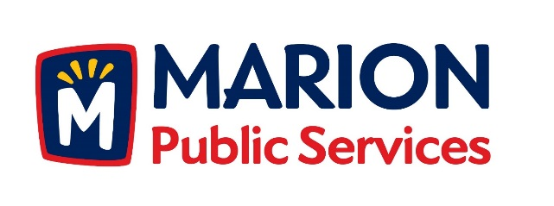

CITY OF MARION PUBLIC SERVICE BOARD
AGENDA
Noon
August 9th, 2016

- Approval of July 2016 Minutes.

- Motion to Approve Application for Solid Waste House Collection Services.
  - Johnson-3114 35th Avenue
  - Wilson-4113 Garnett Circle

- Discussion Regarding Solid Waste Exemptions.

- Discussion Regarding Sanitary Sewer Fees.

- Update on Eco Industrial Development.

- Motion to Approve Engineering Services Agreement with Anderson Bogert (Eco Industrial Park 2nd and 3rd Addition).

- Old Business/New Business.

- Adjournment.

