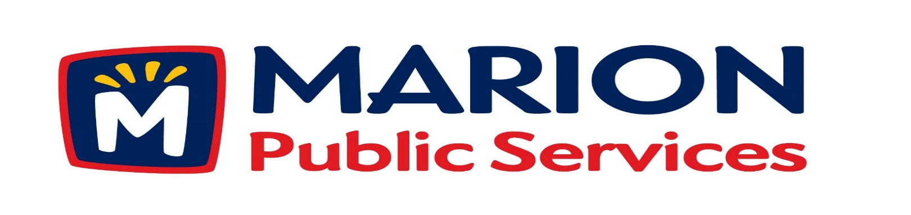

Minutes
Public Services Board
City of Marion
Tuesday, July 12, 2015

Present: Kevin Morgan, Colleen Prokop, Craig Adamson, and Tom Padley
Absent: Tom Morgan
Staff: Ryan Miller and Diane Toy

- Approval of June 2016 Minutes.
- Discussion regarding Assistance for Community Events
- Update on Eco Industrial Development.
- Discussion Regarding Solid Waste Fees and Service for 2016-2017.
- Old Business/New Business.
- Adjournment.

Minutes
Public Services Board
City of Marion
Tuesday, July 12, 2015
Continued

ITEM 1 Approval of June 2016 Minutes.
Craig Adamson called to order the regular meeting of the Public Service Board on Tuesday, July 12, 2016 at 12:05 PM. A motion to approve the June 2016 minutes was made by Colleen Prokop, seconded by Tom Padley, approved by all, Motion carried.

ITEM 2 Discussion Regarding Assistance for Community Events.
Ryan talked about solid waste collection for Community events in the uptown area. In the past we were able to use community credit offered to us by the LC/CR Solid Waste Agency, that credit has stopped but we still do not charge event sponsors for the service. The questions asked are:
- Should we continue this service?
- Do we charge, and what would we charge?
- Do we keep paying for the service and pay for it out of the Solid Waste budget?
Ryan can get a bid from a private hauler to get a base and have some checks and balances for what we do and what a private hauler would do. If we charge the fees would include the cost of the operator, truck, gas and tipping fees.
Craig likes us having control over the service and we should get recognition for the in-kind donation, all PS Board members agreed. Ryan could draft a memorandum to the Chamber and other vendors so they are aware of this in-kind service being provided by the PS Department. They need to know the cost savings and that they need to recognize the PS Department with a letter. The PS Board will need to approve each event that request this service. A motion was made by Kevin Morgan, seconded by Colleen Prokop to approve the event, all members agreed, Motion carried.

Minutes
Public Services Board
City of Marion
Tuesday, July 12, 2015
Continued

ITEM 3 Update on Eco Industrial Development.
Ryan talked to the PS Board about the letter of Intent from the Linn Coop since they received approval from their board to move forward with this project. Ryan and a consultant have come up with a Truck Stop idea with a separate area for trucks. With cars on the other side of the building. This would be the first truck stop in Marion, they did not want to have a convenience store just wanted to keep it simple. Ryan talked about how 44th St was built as a highway and a signal would have to be added on 44th St and Hwy 100 to handle the increased traffic. They also talked about having the tanks above ground, they have some at the current Coop now, they are easier to maintain and can be added to. The following time line is to get the civil report, annex the property is now in Linn County, hopes to have thing done by Spring 2017. A motion was made to move forward with project, made by Craig Adamson, seconded by Colleen Prokop, approved by all, Motion carried.

Item 4 Discussion Regarding Solid Waste Fees and Services for 2016-2017.
Ryan talked about the current cost for solid waste collection, which is $14.00 and the break down is :Planning / Curb side pickup - $10.44, Admin - $1.19, Yard Waste facility - $1.44 and Recycling - $.93 and we also offer a senior rate. Ryan would like to phase out the senior rate and replace it with a hardship option – details to follow. Residents get upset when solid waste rate are increased, but we are still the lowest cost service in the surrounding cities. Tom requested Ryan looks into the low income requirements for water and other cities. The rate increase will be:
Resident: $14.00 to $14.25 Senior: $10.50 to $11.00

Minutes
Public Services Board
City of Marion
Tuesday, July 12, 2015
Continued

Item 4 Discussion Regarding Solid Waste Fees and Services for 2016-2017 con’t.
Recycling income has dropped and the LC/ CR Solid Waste Agency has raised the tipping fee to $85.00/ton for recycling from $34.00/ton last year and they have stopped recycling large plastic so now it must be land filled. We have signed an agreement for one year with the LC/ CR Solid Waste Agency for $34.50, they have also increased the fees for recycling TV’s to $10.00 for 19 inches and less and $15.00 for over 19 inches. The PS Board wanted Ryan to talk to the Council to let them know we may have to come back in 6 months with another increase, if our cost keep rising. Ryan would like to see the approval rate for the Solid Waste Division to be in the 80 – 90 % range. The project Ryan is working on will benefit the residents and be beneficial to the community and environment also. Ryan is still exploring different collection methods and alternate kinds of truck for the project. Ryan is currently meeting with different sources as the project moves forward and has the following questions:
How do we protect the project?
How do we get the info out?
How do we control the information?
Ryan would like to have a plan in place by Fall 2016. He also will look into bringing a contractor to oversee the project.

ITEM 5 Old Business / New Business.
None

Minutes
Public Services Board
City of Marion
Tuesday, July 12, 2015
Continued

ITEM 6 Adjournment
Meeting was adjourned at 1:22PM by Craig Adamson A motion was made to have Ryan move forward with, made by Tom Padley, seconded by Kevin Morgan, approved by all, Motion carried.

Next PSB meeting is scheduled for Tuesday, August 9th, 2016 at noon.

Respectfully submitted by:

____________________
Ryan Miller
Public Service Director

RM/dpt

