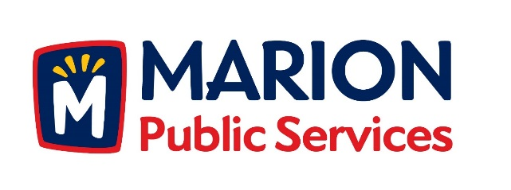

CITY OF MARION PUBLIC SERVICE BOARD
AGENDA
Noon
July 12, 2016

- Approval of June 2016 Minutes.

- Discussion Regarding Assistance for Community Events.

- Update on Eco Industrial Development.

- Discussion Regarding Solid Waste Fees and Services for 2016-2017.

- Old Business/New Business.

- Adjournment.

