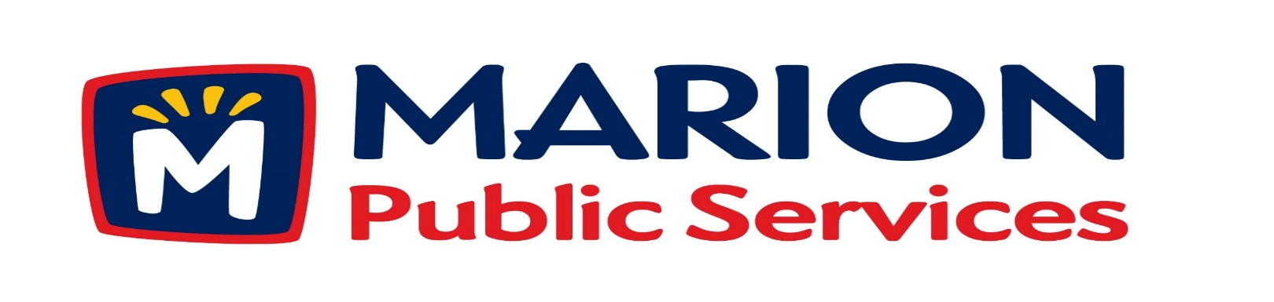

Minutes
Public Services Board
City of Marion
Tuesday, June 14, 2015

Present: Mark Morgan, Colleen Prokop, and Craig Adamson
Absent: Tom Padley, Kevin Morgan
Staff: Ryan Miller and Diane Toy

- Approval of May 2016 Minutes.
- Motion to Approve Application for Solid Waste Fee Exemptions
  - Newhall – 4412 Pepperwood Hill
  - Romick – 2765 14th Avenue
  - Lenoch – 840 7th Avenue
- Discussion regarding Assistance for Community Events
- Motion to approve 28E Maintenance Agreement with Iowa Department of Transportation.
- Motion to Approve Letter of Intent with Linn County Oil Company for Development of Retail Fuel Facilities.
- Motion to Negotiate Purchase and Development Agreement with GVM Equipment.
- Motion to Approve Curbside Recycling Program Incentive with the Cedar Rapids/Linn County Solid Waste Agency.
- Old Business/New Business.
- Adjournment.
Minutes
Public Services Board
City of Marion
Tuesday, June 14, 2015
Continued

ITEM 1 Approval of May 2016 Minutes.
Craig Adamson called to order the regular meeting of the Public Service Board on Tuesday, June 14, 2016 at 12:10 PM. A motion to approve the May 2016 minutes was made by Mark Morgan, seconded by Colleen Prokop, approved by all, Motion carried.

ITEM 2 Motion to Approve application for Solid Waste Services.
Ryan presented the following for approval to be set up as a house pick up, both have been recommended for house pick up by the Solid Waste staff. Newhall at 4412 Pepperwood hill and Rominck at 2765 14th Ave. Mr. Lenoch just purchased the residence at 840 7th Ave which has a business on the first floor and an apartment on the second floor would like to have solid waste service for the apartment. A motion was made by Mark Morgan, seconded by Colleen Prokop to approve the applications, all members agreed, Motion carried.

ITEM 3 Discussion regarding assistance for community events.
JMS Racing Services is requesting assistance of the Public Service Department again this year with the Marion Art Festival race. Ryan meet with John the director of JMS Racing Services and he told Ryan that the company is a non-profit and that the Chamber is handling all the bills. Ryan called and received a low bid from Iowa Plains Signing Inc. of $1850.00. As the day of the race approached John had 3 different routes and kept making changes. Ryan and the staff enjoy helping support nonprofit groups and help the community events. Craig would like to continue to review these events and watch expenses. The PS Board has agreed to bill JMS Racing Services at least $1800.00 to $2000.00 for this year even thought this doesn’t include all cost. Next year Ryan will meet with them in January to review the race route and discuss what services are needed and the costs. A motion was made to approve, made by Craig Adamson, seconded by Colleen Prokop, approved by all, Motion carried.
Minutes
Public Services Board
City of Marion
Tuesday, June 14, 2015
Continued

Item 4 Motion to Approve 28E Maintenance Agreement with IDOT.
Ryan presented the IDOT 28E agreement that is reviewed every 5 years, this details who is responsible for which roads are maintained by which party – roads only. We maintain all traffic signals – HWY 13, HWY 100. Last looked at in 2011, Ryan feels everyone is doing a good job maintaining their part of the agreement. A motion was made to approve, made by Craig Adamson, seconded by Colleen Prokop, approved by all, Motion carried.

ITEM 5 Motion to Approve letter of Intent With Linn County Oil Company for Development of Retail Fuel Facilities.
Ryan updated the PS Board about conversations he has had with the Linn Co-op and that they went to their Board to talk about the opportunity to partner with Marion Public Service on this project. They have to rebuild and replace their pumps in the next year. They will lease the facility from us and run the complete operation. Their current location would not have pumps and be for car repair facility. The new location would be fuel and large truck repair. Linn Co-op will man the facility and would like to have a retail area that would be an indoor farmers market. We would like to move ahead, but we must stay focused on the cost and functionality of the building. A motion was made to approve, made by Mark Morgan, seconded by Colleen Prokop, approved by all, Motion carried.

Minutes
Public Services Board
City of Marion
Tuesday, June 14, 2015
Continued

ITEM 6 Motion to Negotiate Purchase and Development Agreement with GVM Equipment.
GVM Equipment Co is the company Ryan looked at for the special chassis, the company is ready to go commercial and want us to be a test facility for them. This chassis will accommodate any kind of apparatus (ie: box, flat bed, and hook). The parts are available locally so we would be able to maintain the equipment and they are low maintenance because they are built like a tractor. Market cost / price is $300,000.00 and our cost would be approximately $170,000.00. A motion was made to approve, made by Craig Adamson, seconded by Colleen Prokop, approved by all, Motion carried.

ITEM 7 Motion to approve Curbside Recycling Program Incentive with the Cedar Rapids / Linn County Solid Waste Agency.
Ryan talked about the new contract with CR/LC Solid Waste Agency for the recycling program. The cost is $65.00 / ton for the CR/LC Solid Waste Agency to take the recycling to Republic Services and they have updated their recycling facility and the recycling market has dropped in price and markets. We will agree to the $14.00 / ton price for one year. Ryan will be watching the costs from CR/LC Solid Waste Agency. Private haulers are being charged $85.00 / ton, so they have stopped offering their customers recycling services because they cannot afford the cost increase. Ryan will continue to look into different ways to recycle items collected in different cost effective ways. A motion was made by Mark Morgan, seconded by Colleen Prokop, all members agreed, Motion carried.

Minutes
Public Services Board
City of Marion
Tuesday, June 14, 2015
Continued

ITEM 8 Old Business / New Business.
Looking for a low cost sprayer.
Tower Terrace Rd 7 10th St curb is chipping and crumbling and pieces are in the road.
31st St & 10th Ave by YMCA storm intake has debris in it.
Update on Art in the Alley project.

ITEM 7 Adjournment
Meeting was adjourned at 1:25PM by Craig Adamson. A motion was made by Mark Morgan, seconded by Colleen Prokup, and all Board members are in favor, Motion carried.
Next PSB meeting is scheduled for Tuesday, July 12th, 2016 at noon.

Respectfully submitted by:

____________________
Ryan Miller
Public Service Director

RM/dpt

