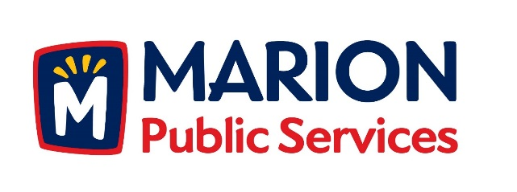

CITY OF MARION PUBLIC SERVICE BOARD
AGENDA
Noon
June 14th, 2016

- Approval of May 2016 Minutes.

- Motion To Approve Application For Solid Waste Services

  - Newhall-4412 Pepperwood Hill
  - Romick-2765 14th Avenue
  - Lenoch- 840 7th Avenue

- Discussion Regarding Assistance for Community Events.

4. Motion To Approve 28E Maintenance Agreement With Iowa Department Of Transportation.

5. Motion To Approve Letter Of Intent With Linn County Oil Company For Development Of Retail Fuel Facilities.

- Motion to Negotiate Purchase and Development Agreement with GVM Equipment.

- Motion to Approve Curbside Recycling Program Incentive with the Cedar Rapids/Linn County Solid Waste Agency.

- Old Business/New Business.

- Adjournment.

