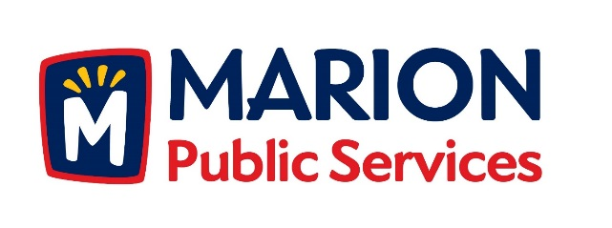

CITY OF MARION PUBLIC SERVICE BOARD
AGENDA
Noon
May 10, 2016

- Approval of April Minutes.

- Motion to Approve Application for Solid Waste Fee Exemptions

  - Floyd-3365 Sunburst Avenue

- Discussion regarding assistance for community events (Marion Arts Festival).

4. Motion to approve job description for Seasonal Maintenance Employee .

5. Update on Eco Industrial Park Development.

- Old Business/New Business.

- Adjournment.

