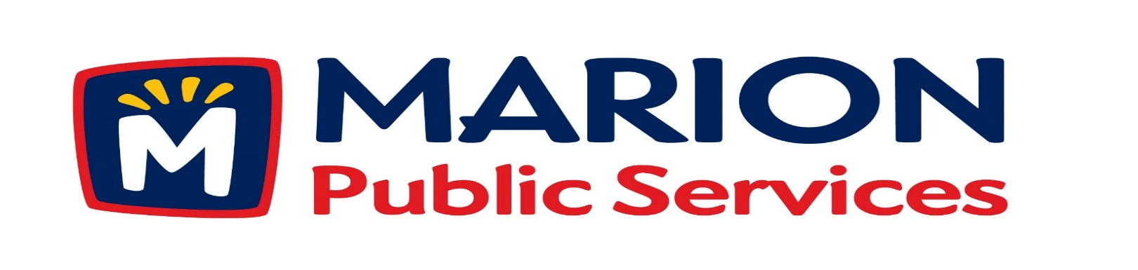

Minutes
Public Services Board
City of Marion
Tuesday, March 8, 2015

Present: Mark Morgan, Kevin Morgan, Colleen Prokop, Tom Padley and Craig Adamson
Staff: Ryan Miller and Diane Toy

- Approval of February 2016 Minutes.
- Motion to Approve Solid Waste Exemption.
- Motion to Approve Commercial Solid Waste District Designation for Properties Located Between the 1000 and 1100 block of 7th and 8th Avenue (Art in the Alley Project).
- Motion to Approve Temporary Commercial Solid Waste Collection Fee.
- Discussion Regarding Solid Waste Collections.
- Update on Eco Industrial Park.
- Old Business/New Business.
- Adjournment.

Minutes
Public Services Board
City of Marion
Tuesday, March 8, 2015
Continued

ITEM 1 Approval of February 2016 Minutes
Craig Adamson called to order the regular meeting of the Public Service Board on Tuesday, March 8, 2016 at 12:15 PM. A motion to approve the February 2016 minutes was made by Mark Morgan, seconded by Kevin Morgan, approved by all, Motion carried.

ITEM 2 Motion to Approve application for Solid Waste Exemption.
Mr. Platten has built a new house in Marion, but has not sold his former house. He is asking the PS Board to approve his exemption from paying Solid Waste at both residents. He has short paid the billing and was tagged a charged a late fee of $32.10. He is asking the PS Board waive the 180 day exemption. Craig wanted to know if this is easy to track that a vacate residence never has solid waste out, this is hard to track and inforce because sometimes a neighbor will put Solid waste out at the resident. It was discussed that if the resident should follow the water ordinance and turn of both water and solid waste service, too hard to track just solid waste with new software. A resident must be gone for the whole billing cycle after the 180 days to have solid waste charges turned off. A motion was made by Mark Morgan, seconded by Colleen Prokop to deny this request and up hold the current city ordinance, all members agreed, Motion carried.

Minutes
Public Services Board
City of Marion
Tuesday, March 8, 2015
Continued

ITEM 3 Motion to Approve Commercial Solid Waste District Designation for Prperties Located between the 1000 and 1100 block of 7th and 8th Ave (Art in the Alley Project).
Ryan updated the PS Board about the Art in the Alley Project and that there 6 to 7 private dumpsters in the alleys in the Uptown area and once the work starts on the project garbage trucks will not be able to empty the dumpsters. If the motion is approved Ryan will send out a letter to the companies to remove the dumpsters during the project and we will place 2 roll off dumpsters in the uptown area for the businesses to use and we will charge them a reduced fee during the construction time of about 7 months. Fees would be charged by the amount of garbage produced by each business. New ordinance 16-02 chapter 105 that the PS Board can change at any time during the construction period. A motion was made by Mark Morgan, seconded by Colleen Prokop, all members agreed, Motion carried.

Item 4 Motion to Approve Temporary Commercial Solid Waste Collection Fees.
The cost are listed below during the temporary collections during the construction period:
96 gal $20.00
2 yard dumpster $82.50
3 yard dumpster $96.50
10 yard container $190.00
A motion was made to approve the fees was made by Mark Morgan, seconded by Kevin Morgan, approved by all, Motion carried.
Minutes
Public Services Board
City of Marion
Tuesday, March 8, 2015
Continued

ITEM 5 Discussion Regarding Solid Waste Collections.
Ryan updated the PS Board about a trip to Muncie, IN to talk to them about their Solid Waste collection program. Their fleet is CNG and completely automated, they have 35,000 customers and each drivers collects 1,000 customers per day and are done by 1:00PM. Ryan was looking at cab over chassis trucks built by Autocar.
Ryan also updated the PS Board on our collection system and our trucks. Thoughts on automated collection? Cedar Rapids is doing it now and their fees are $19.00 per month and our fees are $14.00 per month doing it manually.

ITEM 6 Update on Eco Industrial Park.
Ryan updated the PS Board on the plans for the Eco Industrial Park and that the City Council had approved the purchase of some additional land and plans are moving forward. Ryan has been talking to private companies to partner with the City on some aspects of the project. Ryan is working on finalizing some of the design plans so the project can move forward. Ryan will keep the PS Board up to date on the progress on the Eco Industrial Park.

ITEM 7 Old Business / New Business
New business: Updated the PS board about the demolition of the old Police building.

Minutes
Public Services Board
City of Marion
Tuesday, March 8, 2015
Continued

ITEM 8 Adjournment
Meeting was adjourned at 1:30PM by Craig Adamson. A motion was made by Mark Morgan, seconded by Colleen Prokup, and all Board members are in favor, Motion carried.

Next PSB meeting is scheduled for Tuesday, April 12^{th,} 2016 at noon.

Respectfully submitted by:

____________________
Ryan Miller
Public Service Director

RM/dpt

