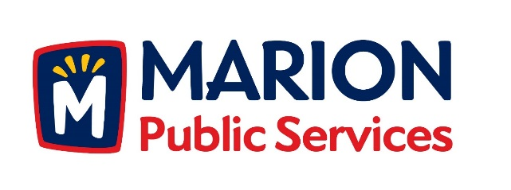

CITY OF MARION PUBLIC SERVICE BOARD
AGENDA
Noon
April 12th, 2016

- Approval of March Minutes.

- Motion to Approve Application for Solid Waste House Pick Ups

  - Rutherford 4310 Indian Creek Road
  - Valentine 2315 Northview Drive

- Discussion Regarding Seasonal Employment (Steve Dorothy).

4. Discussion regarding duties of the Public Service Board.

5. Motion to Approve Development Agreement with LifeCycle Energy.

6. Motion to Approve Seasonal Work Schedule for 2016.

7. City of Marion Board/Commission Ethics Policy

8. Old Business/New Business.

9. Adjournment.

