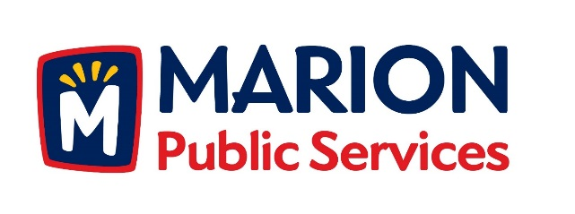

CITY OF MARION PUBLIC SERVICE BOARD
AGENDA
Noon
March 8, 2016

- Approval of February Minutes.

- Motion to Approve Application for Solid Waste Exemptions.

3. Motion to Approve Commercial Solid Waste District Designation for Properties Located Between the 1000 and 1100 block of 7th and 8th Avenue (Art in the Alley Project).

4. Motion to Approve Temporary Commercial Solid Waste Fee Collections.

5. Discussion Regarding Solid Waste Collections.

6. Update on Eco Industrial Park

7. Old Business/New Business.

8. Adjournment.

