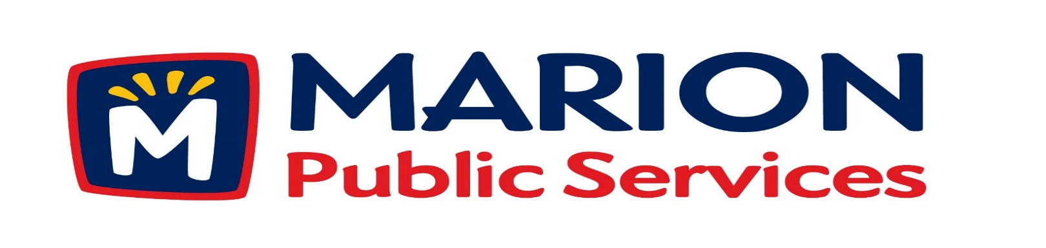

Minutes
Public Services Board
City of Marion
Tuesday, February 9, 2015

Present: Mark Morgan, Kevin Morgan, and Colleen Prokop
Absent: Tom Padley and Craig Adamson
Staff: Ryan Miller and Diane Toy

- Approval of January 2016 Minutes.
- Motion to Approve Solid Waste Holiday Schedule.
- Motion to Receive and File Job Description for Maintenance Specialist Positions.
- Discussion Regarding Commercial Solid Waste Collections.
- Discussion Regarding Eco Industrial Park.
- Discussion Regarding the Public Service Board.
- Old Business/New Business.
- Adjournment.

Minutes
Public Services Board
City of Marion
Tuesday, February 9, 2015
Continued

ITEM 1 Approval of January 2016 Minutes
Mark Morgan called to order the regular meeting of the Public Service Board on Tuesday, February 9, 2015 at 12:17 PM. A motion to approve the January 2016 minutes was made by Colleen Prokop, seconded by Kevin Morgan, approved by all, Motion carried.

ITEM 2 Motion to Approve Solid Waste Holiday Collection Schedule
Ryan suggested to the PS Board that we approve the Solid Waste Holiday Schedule through November 2016 and have him talk to the Solid Waste Supervisor to decide on the Christmas and New Year’s pick up schedule with the holiday being on a Saturday. A motion was made by Colleen Prokop, seconded by Mark Morgan, all members agreed, Motion carried.

ITEM 3 Motion to Receive and File Job Description for Maintenance Specialist Position.
This is a new position which will allow for advancement, leadership and is a non-bargaining position, by creating positions like this will allow employees to grow within a job. This will be a pay for performance position and will receive a raise once a year and the pay scales will be very flexible for and wide range for a position to give an employee room for growth. If motion is approved Ryan will take the request to the City Council. A motion was made by Mark Morgan, seconded by Colleen Prokop, all members agreed, Motion carried.

Minutes
Public Services Board
City of Marion
Tuesday, February 8, 2015
Continued

ITEM 4 Discussion Regarding Commercial Solid Waste Collection.
Ryan updated the PS Board about City Ordinance Chapter 105 Solid Waste Control, residential units 5 or less are collected by the City and over 5 units and businesses are collected by private collectors. With the Art in the Alleyways project moving forward we need to have a very controlled SW collection program in place. Ryan is looking into different options to collect and empty dumpsters with a small truck, the conversion would cost approximately $9000.00 and dumpsters can cost $500.00 to $1500.00 depending upon the size. The PS Board would approve every new commercial pick up located in the Uptown area and City facilities and then it will be approved by the City Council. Collection rates would be looked at and approved by the PS Board annually or bi-annually and would go to the City Council for approval. We would be able to handle this type of collection with the current staff. A motion was made by Colleen Prokop to approve the recommendation and move forward with the amendment and present it to the City Council seconded by Kevin Morgan, and all Board members are in favor, Motion carried.

ITEM 5 Discussion regarding Eco Industrial Park.
Ryan updated the PS Board about the plans for the Eco Industrial Park: An Eco Industrial Park is where companies form partnerships with each other on the different operations within the Industrial Park. The City Council approved the purchase of 2 parcels of land off 44th street. We have outgrown our current compost area and are using about 10 acres of the new land, the new way to make the compost is very efficient and takes up more land.

Minutes
Public Services Board
City of Marion
Tuesday, February 8, 2015
Continued

ITEM 6 Discussion Regarding the Public Services Board.
The Ordinance is 20 years old and needs to be updated and items that need to be reviewed are Chapter 26: Duties and Responsibilities of the Board and Department.
We need to create a procedure for Board member nominations and terms of service. Ryan would like to discuss expansion of the PS Board to include outside members that would have input and opinions, but would not be voting members. Ryan will start drafting up a new ordinance to bring to the PS Board for input.
A motion was made by Colleen Prokop to approve the recommendation and move forward with the Ordinance and present it to the PS Board for further discussion, seconded by Kevin Morgan, and all Board members are in favor, Motion carried.

ITEM 6 Old Business / New Business
New business: New City Council members.

ITEM 7 Adjournment
Meeting was adjourned at 1:42PM by Mark Morgan. A motion was made by Kevin Morgan, seconded by Colleen Prokup, and all Board members are in favor, Motion carried.

Next PSB meeting is scheduled for Tuesday, March 8^{th,} 2016 at noon.

Minutes
Public Services Board
City of Marion
Tuesday, February 8, 2015
Continued

Respectfully submitted by:

____________________
Ryan Miller
Public Service Director

RM/dpt

