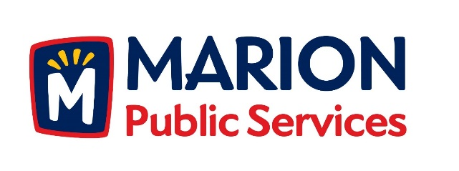

CITY OF MARION PUBLIC SERVICE BOARD
AGENDA
Noon
FEBRUARY 9, 2016

- Approval of January Minutes.

- Motion to Approve Solid Waste Holiday Collection Schedule

3. Motion to Receive and File Job Description for Maintenance Specialist Positions.

4. Discussion Regarding Commercial Solid Waste Collections.

5. Discussion Regarding Eco Industrial Park.

6. Discussion Regarding the Public Services Board.

7. Old Business/New Business.

8. Adjournment.

