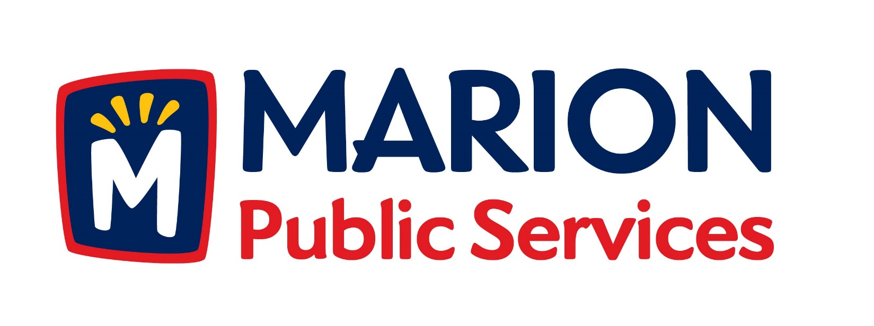
Minutes
Public Services Board
City of Marion
Tuesday, December 8, 2015

Present: Craig Adamson, Mark Morgan, and Colleen Prokop
Absent: Tom Padley and Kevin Morgan
Staff: Ryan Miller and Diane Toy

- Approval of November 2015 Minutes.
- Motion to Approve house Pickup Request:
  - Nassif/Collins – 3030 Diamond Lane
- Motion to file application for financial assistance for fuel systems development:
  - Renewable Fuel Infrastructure Program – IDALS
  - Biofuels Infrastructure Program - USDA
- Motion directing staff to complete plans and specifications for the Eco-Industrial Park Development.
- Discussion regarding Public Services Budget for 2016/2017 Fiscal Year.
- Old Business/New Business.
- Adjournment.

Minutes
Public Services Board
City of Marion
Tuesday, December 8, 2015
Continued

ITEM 1 Approval of September 2015 Minutes
Craig Adamson called to order the regular meeting of the Public Service Board on Tuesday, December 8, 2015 at 12:09 PM. A motion to approve the November 2015 minutes was made by Mark Morgan, seconded by Colleen Prokop, approved by all, Motion carried.

ITEM 2 Motion to Approve House Pickup
A request for a house pickup at 3030 Diamond Ln., resident is a disabled vet. Resident has request that this resident become a house pick up. A motion was made by Mark Morgan, seconded by Colleen Prokop, all members agreed, Motion carried.

ITEM 3 Motion to file application for financial assistance for fuel systems development.
Ryan updated the PS Board about the grants that are available for up to $100,000 per project from the Iowa Department of Agriculture and Land Steward and a Biofuel Infrastructure program for tanks and pumps at Natural Gas filling station. Ryan is talking to ANGI Energy System, they build natural gas facilities. We are looking at a 500-600 gallon size station and the cost will be 500 to 700 thousand dollars to build. Iowa fuel tax changes effective 7/1/15. Ryan is looking into how to get a natural gas line to the Marion Airport. We will have an unmanned quick fill station, our trucks will be filled up in 60 seconds. Ryan has been watching the fuel prices from the Des Moines terminal and what we are paying, on 12/7/15 Diesel # 2 was 1.3153 and 12/8/15 it was 1.2622, Craig asked How much of a savings would we have if we purchased it from the Des Moines terminal for the station? About 40,000 to 50,000 per year. Natural gas prices are locked into a 3 year contract. Ryan goal is to get a public station and a private station for the City to use. We will not be taking away or competing with local businesses we are leading them in that direction.
Minutes
Public Services Board
City of Marion
Tuesday, December 8, 2015
Continued

ITEM 3 Motion to file application for financial assistance for fuel systems development continued.
Craig would like a formal letter from the Boards of any business that is not interested in being part of a joint venture with the City of Marion Public Service, so no one can say we are competing for business verses leading. Acterra is working with us and the PS Board would like this presented to City Council. We will be limited as to where we can put the station as to the location of the pipe. Ryan would like to open up the cost saving to the school districts for lower cost CNG.
A motion was made by Craig Adamson to file the applications, seconded by Colleen Prokup, and all Board members are in favor, Motion carried.

ITEM 4 Motion directing staff to complete plans and specifications for the Eco-Industrial Park Development.
Ryan updated the PS Board about the site plans for the new facility: Structural plans for a new building on the new property behind our current facility, water and sewer are in at this time only thing to add is electricity. Alliant would like to put in a solar garden on our land, the agreement will come to the PS Board for approval, and the goal is to be a benefit to the community. We will have to submit the plans to the Army Corps of Engineers for approval due to all the wetland on the property. We will be able to use any solar panel distributor not just Alliant. The recycling center will be an inside drop off facility A new building will get us by for the next 30 years, with a goal to plan a low maintenance facility, the total is 48 acers of land. A motion was made by Craig Adamson to approve the plans to move forward, seconded by Mark Morgan, and all Board members are in favor, Motion carried.

ITEM 5 Discussion regarding Public Service Budget for 2016/2017 Fiscal Year
Ryan wanted to table this item until the next month.

Minutes
Public Services Board
City of Marion
Tuesday, December 8, 2015
Continued

ITEM 6 Old Business / New Business
Old business:
New business: How much compost do we have? Our supply is good and we have a surplus, the new process it is ready in 6-8 weeks verses 6 months.

ITEM 7 Adjournment
Meeting was adjourned at 1:40PM by Craig Adamson. A motion was made by Mark Morgan, seconded by Colleen Prokup, and all Board members are in favor, Motion carried.

Next PSB meeting is scheduled for Tuesday, January 12th 2016 at noon.

Respectfully submitted by:

____________________
Ryan Miller
Public Service Director

RM/dpt

